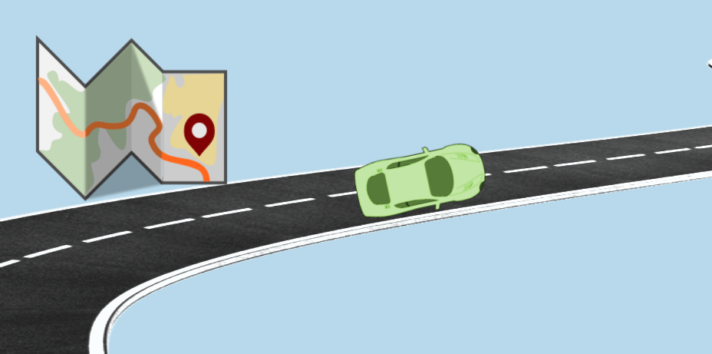 | You’re in the Driver’s Seat:  A Classroom Roadmap for Supporting All Students  Resource List

Supporting and Responding to Students’ Social-Emotional-Behavioral Needs
This guide summarizes evidence-based, positive, and proactive practices that support and respond to students’ social, emotional, and behavioral (SEB) needs in classrooms and similar teaching and learning environments.
https://www.pbis.org/resource/supporting-and-responding-to-behavior-evidence-based-classroom-strategies-for-teachers

Positive Greetings at the Door
Positive greetings at the door is an effective strategy for increasing academic engagement, decreasing unwanted behavior, and improving student-teacher relationships. This strategy brief breaks it down into easy steps for daily implementation.
https://www.pbis.org/resource/positive-greetings-at-the-door

Creating a Classroom Teaching Matrix

This brief provides guidance for creating and using a classroom teaching matrix to explicitly identify, define, and teach (a) predictable classroom routines, (b) positive classroom expectations, and (c) critical social, emotional, and behavioral (SEB) skills.

https://www.pbis.org/resource/creating-a-classroom-teaching-matrix

Supporting and Responding to Educators’ Classroom PBIS Implementation Needs: Guide to Classroom Systems and Data
This guide provides updated guidance on how to (a) develop systems to support educators’ implementation of evidence-based classroom practices and (b) use data to guide the development of implementation supports.
https://www.pbis.org/resource/pbis-technical-brief-on-systems-to-support-teachers-implementation-of-positive-classroom-behavior-support

Multi-Tiered System of Supports (MTSS) in the Classroom
This guide will help educators familiar with PBIS organize classroom supports for preventing, teaching, and responding to students’ social, emotional, and behavioral (SEB) needs across the continuum.
https://www.pbis.org/resource/multi-tiered-system-of-supports-mtss-in-the-classroom
_________________________________________________________________

