You’re in the Driver’s Seat:
A Classroom Roadmap for Supporting ALL Students
Participant Guide
Karen Robbie, Ph.D.
University of Connecticut
Sarah Wilkinson, Ph.D.
University of Southern Maine
Laura Kern, Ph.D., J.D.
University of South Florida
Janet VanLone Ph.D.
Bucknell University

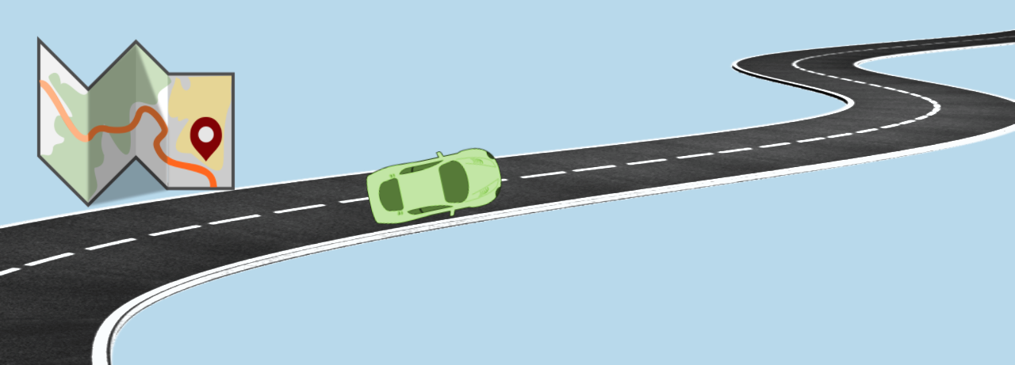
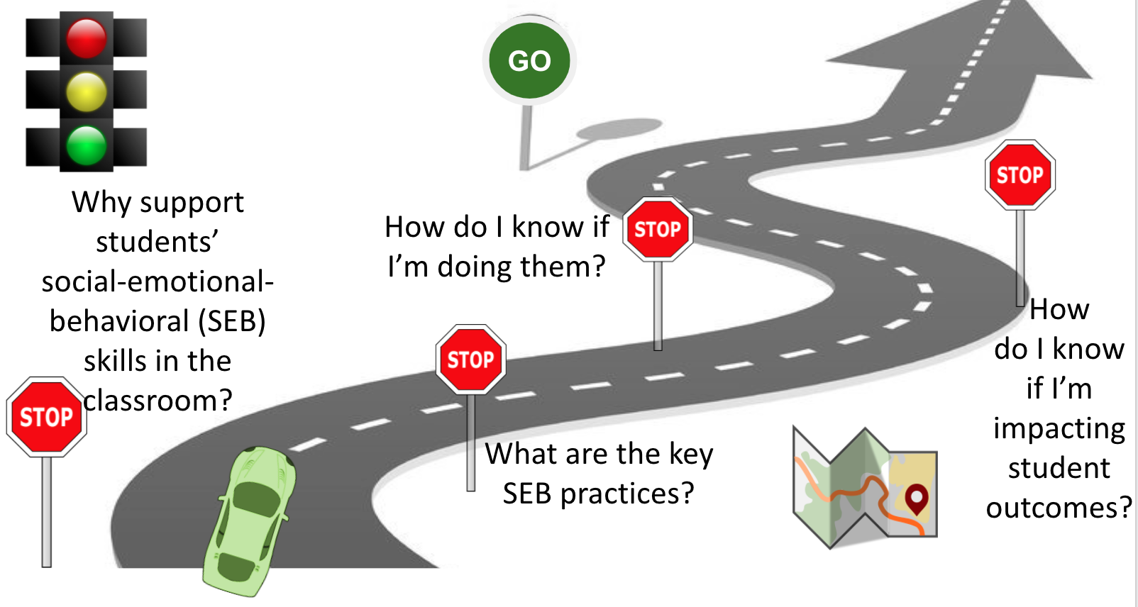
Why support students’ social-emotional-behavioral (SEB) skills in the classroom?

NOTES
What is YOUR why?
What is your key takeaway from this section?
How will you apply it to your setting?

What are the key SEB practices?

NOTES

Creating Effective Classroom Practices Template
Center on PBIS (2020, July). Creating Effective Classroom Environments Plan Template.

Complete tables with your own information by deleting & replacing light blue example text. Consider either (a) developing separate plans for in-person & remote instruction or (b) including examples across contexts

Positive Classroom Expectations Look Like, Sound Like, Feel Like in….

Expectations | Routines | Teacher-  Directed Instruction | Small Group Activities | Independent Work | Transitions | …
1. Kind to self |  | - Use whole body listening | - Share your ideas | - Do your best  - Ask for help if you need it | - Bring what you need to be ready for what’s next
2. Kind to others |  | - Calm body & quiet voice  - Mute tech | - Actively listen  - Take turns  - Wear a mask | - Calm body & quiet voice  - Stay in your own space | - Quiet voice  - Keep a 6’ space bubble
3. Kind to environment |  | - Take care of your space | - Take care of your space & materials | - Take care of your space & materials | - Leave space better than you found it
…

Plan high rate/quality of opportunities to respond (active engagement) for students.
Academic content | Strategy to use

Prompt Expected Behavior… | Prompt Examples:
...at the beginning of each activity | - “While I’m reading, you can be kind by keeping your body calm, voice quiet, tech muted, and eyes on me. “
…prior to the end of each activity | - “In 1 minute, we’re going to do our next activity. Please be kind to your space by putting your materials away, sanitizing your space, and leaving it better than you found it.”
…before each transition | - “Remember, as we walk, we will be kind by keeping our voices quiet and a 6’ bubble of space around our bodies. ”

Give Specific Feedback … | Praise/Correction Examples:
...for desired behavior (praise) | - “Wow. I like how you are being kind by helping you friend with her materials.”  - “Class, you are being kind to yourselves by being ready to learn…this is going to be a fun and important lesson.”
…for undesired behavior (correction) | - “I see materials that are not put away. Group 1, please return to your area and show that you can leave the space even better than you found it.”  - “I see that not everyone has had a chance to participate in the group activity. Please mute after your turn and be sure you are kind and give everyone a chance to share their ideas.”

Social Skills Lesson Plan Template

Lesson Focus:
Demonstrating _________________ (expectation) in the _________________ (setting/routine).

Teaching Objective:
Following instruction, students will demonstrate _________________ (expectation) in the _________________ (setting/routine) by_________________________________(describe behaviors) across __ out of __ sampled opportunities (criteria).

Teaching Examples:
Positive Examples  (Looks, sounds, & feels like…) | Negative Examples  (Does NOT look, sound, & feel like…)

Lesson Materials:

Lesson Activities:
Model (I do):

Lead (We do):

Test (You do):

Follow-up Activities:
Strategies to prompt:

Procedures to reinforce context-appropriate behavior:

Procedures to correct errors (e.g., context-inappropriate behavior):

Procedures to monitor/supervise:

Procedures to collect and evaluate student data:

What is your key takeaway from this section?
How will you apply it to your setting?

How do I know if I’m doing them?

NOTES

Supporting and Responding to Student’s Social, Emotional, and Behavioral Needs: Evidence-based Practices for Educators (Self-Assessment and Action Plan)
Center on PBIS. (2021). Supporting and responding to student’s social, emotional, and behavioral needs: Evidence-based practices for educators (Version 2.0). Center on PBIS, University of Oregon.

Complete the self-assessment to gauge current implementation of classroom practices. For each item: (a) review the supporting table; (b) self-assess whether practice is fully, partially, or not at all implemented; (c) rate priority (low, medium, high) for action planning; (d) celebrate fully implemented high-priority practices; and (e) action plan to support implementation of top 3 priorities with low implementation (rates as implementing partially or not at all).

Steps to Support and Respond to Students’ SEB Needs | Self-assess implementation |  |  | Priority for action planning
Create positive teaching and learning environments (Table 1) | Fully | Partially | Not at all | Low | Med | High
1.1 The classroom environment (layout, furniture, materials, visuals) is safe and accessible.
1.2 I have established positive connections among students and families, through purposeful and regular communication, to learn about my students and actively engage families.
1.3 I post, teach, practice, and review predictable routines collaboratively with students.
1.4 I have co-developed, defined, explicitly taught, and reviewed a few positive classroom expectations collaboratively with students.
1.5 I engage students in planning relevant instruction that celebrates diversity, prioritizes relevant curriculum, incorporates appropriate task dimensions, and differentiates supports.
Actively promote social, emotional, and behavioral growth (Table 2)
2.1 I use explicit instruction, with high rates of varied opportunities to respond, to engage students in relevant learning
2.2 I foster positive relationships among students, families, and educators by greeting, engaging, and considering preferences throughout activities in a collaborative manner
2.3 I prompt and supervise SEB and academic skills by prompting skills, helping students prompt themselves, actively monitoring/ supervising, and individualizing prompts when helpful.
2.4 I provide specific feedback to support SEB and academic skill growth, and I exceed a ratio of 5 specific praise statements for each supportive corrective statement (≥5:1 ratio).
2.5 I consider and implement other response strategies, when appropriate, to reinforce SEB and academic skill growth and prevent/ respond to SEB and academic errors
Monitor fidelity & use data to guide implementation (Table 3)
3.1 In addition to this self-assessment, I monitor implementation fidelity of classroom practices to assess quantity and quality of implementation, from multiple perspectives, across time.
3.2 Based on fidelity data, I have a plan (see action plan template) to access training, coaching, and supportive data-based feedback to enhance implementation of key practices
Monitor student outcomes & use data to guide response (Table 4)
4.1 I collect, disaggregate, and review data to monitor student outcome and guide support.
4.2 If many students demonstrate on-going risk/need, I enhance Tier 1.
4.3 If few students demonstrate on-going risk/need, I also consider targeted (Tier 2) or intensive (Tier 3) support.

Action Plan
Why?  (Priority) | What?  (Action steps to enhance implementation) | Who?  (Implementer) | When?  (Due date) | What else?  (Notes or additional details)
Sample  My self-assessment of item 2.4 and fidelity (item 3.1) data indicate my positive to corrective feedback ratio is 1:1, and I do not have a plan (item 3.2), but improving specific feedback is high priority (item 2.4) | - Set goal for improving praise ratio to 5:1 (5 positives for each corrective) during at least one instructional routine  - Use Be+ App to track positive and corrective feedback during that routine  - On days where my ratio is >5:1, celebrate by stopping by my favorite coffee shop on the way home  - On days where my ratio is <5:1, practice praise statements to use the next day | - Me | - Monitor daily (enter  - data by end of each day)  - In 2 weeks,  - review data with mentor | - Continue daily monitoring until I’ve met my goals for 10 days in a row  - Then, continue to spot-check my ratio 1-2 times a week (and resume daily monitoring if it dips below 5:1)  - If my ratio does not improve, ask mentor for help

What is your key takeaway from this section?
How will you apply it to your setting?

How do I know if I’m impacting student outcomes?

NOTES

Differentiating Student Behavior Support in the Classroom
 | Student 1 | Student 2
Operationally DEFINE the behavior
What does it look and sound like?
Identify 1-2 strategies you will implement over the next month to differentiate behavior support
How will you monitor your implementation of those strategies?
How will you monitor student response to those strategies?

What is your key takeaway from this section?
How will you apply it to your setting?

